Experiment – 04 Study and Verification of Standard Network Topologies

Lab Objective:
To understand and verify the structure and functioning of various standard network topologies, specifically Star, Bus, and Ring. This includes learning how these topologies are physically and logically implemented and how they behave in a network environment.

Prerequisites:
- Basic understanding of computer networks
- Knowledge of networking devices (like switches, hubs, NICs)
- Familiarity with IP addressing and network configuration

Network Topologies – Overview:
A network topology refers to the arrangement of different elements (links, nodes, etc.) in a computer network. It can be physical (actual layout of cables and devices) or logical (the way data flows within the network).
The common types of network topologies include:

1. Star Topology:
Structure:
- All computers (nodes) are connected to a central device (hub or switch).
- Each device has a dedicated point-to-point link to the hub/switch.
Advantages:
- Easy to install and manage
- If one cable fails, only that specific node is affected
- Centralized management
Disadvantages:
- If the central hub/switch fails, the whole network goes down
- Requires more cable than bus or ring
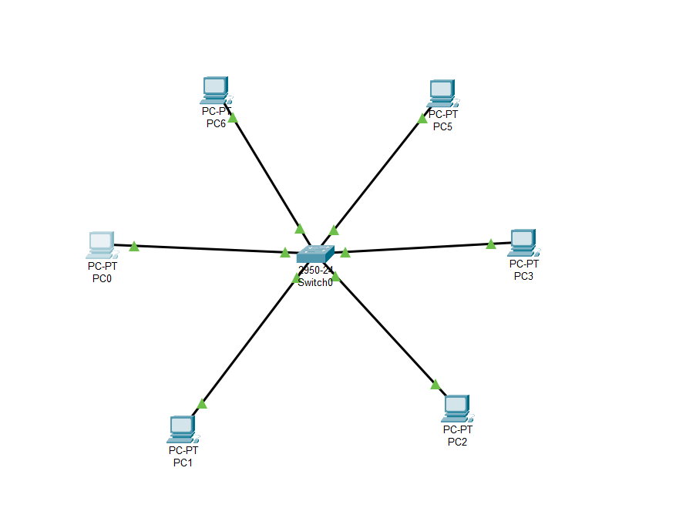

2. Bus Topology:
Structure:
- All computers are connected to a single central cable (called the backbone).
- Data is sent in both directions and received by all devices, but only the intended recipient accepts and processes it.
Advantages:
- Easy to implement and extend
- Requires less cable compared to star topology
Disadvantages:
- Difficult to troubleshoot
- A failure in the backbone affects the entire network
- Data collisions are common in large networks
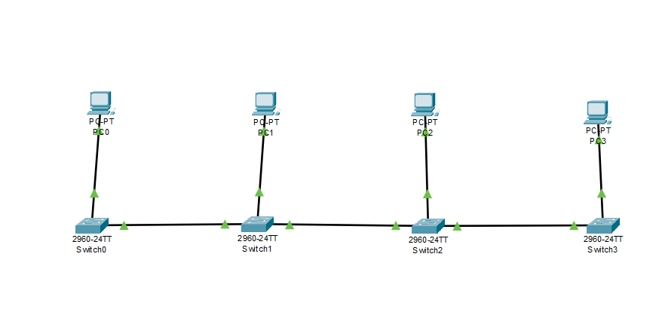

3. Ring Topology:
Structure:
- Each computer is connected to two other computers, forming a circular (ring-like) network.
- Data travels in one direction (unidirectional) or both directions (bidirectional in dual-ring).
Advantages:
- Equal access for all nodes
- Good performance under heavy load
Disadvantages:
- A single node or cable failure can disrupt the entire network (unless a dual-ring or fault-tolerant system is used)
- Difficult to reconfigure and troubleshoot
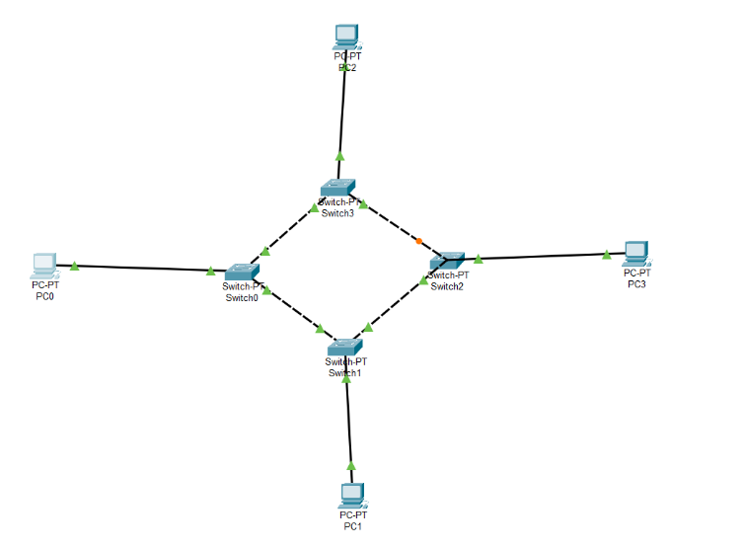

Outcome:
By the end of this experiment, students will be able to:
- Identify and set up different network topologies
- Understand their structure and performance characteristics
- Observe how data flows through each topology
- Configure network settings and ensure inter-device communication

Steps for Verifying Ring Topology:
Step 1: Gather Required Hardware
- Computers or laptops with Network Interface Cards (NICs)
- Network cables (Ethernet)
- Switches or connectors if needed
Step 2: Physical Setup
- Connect each computer to the next in a circular manner using Ethernet cables.
- Ensure that the last computer is connected back to the first to complete the ring.
- Example: PC1 → PC2 → PC3 → PC4 → PC1
Step 3: Network Configuration
- Assign IP addresses to all computers within the same network range.
  - Example:
    - PC1: 192.168.1.1
    - PC2: 192.168.1.2
    - PC3: 192.168.1.3
    - PC4: 192.168.1.4
- Set the same subnet mask (e.g., 255.255.255.0)
- Ensure all computers can ping each other successfully.
Step 4: Verification
- Use the ping command to test connectivity between the computers.
- Observe the data flow and check if the communication is successful.
- Simulate node failure (e.g., disconnect one PC) and observe the impact on the network.

Conclusion:
Through this experiment, we gained a hands-on understanding of how standard topologies work, how to set them up, and their practical advantages and disadvantages. Among all, Star is the most widely used in modern networks due to its simplicity and reliability, while Bus and Ring are mostly found in legacy systems or academic demonstrations.

